Case Study 9: Text Compression

1. Problem Statement
Replace each group of consecutive repeated characters with the character and its count.

2. Objectives
- Find repeated consecutive characters.
- Display a simple compressed string.

3. Assumptions
- Input should not contain spaces for this beginner version.
- Every character is followed by its count.

4. Algorithm
1. Read text.
2. Count consecutive matching characters.
3. Append each character and count to the result.
4. Display compressed text.

5. Flowchart
START → Read text → Count consecutive characters → Build encoded text → Display → STOP
For a drawn flowchart, use: oval for START/STOP, parallelogram for input/output, rectangle for calculations, and diamond for decisions.

6. Pseudocode
READ text
IF text is empty: DISPLAY empty
ELSE SET encoded = empty, count = 1
SCAN each next character
IF same as previous: increase count; ELSE append previous and count
Append last character and count
DISPLAY encoded

7. Python Source Code
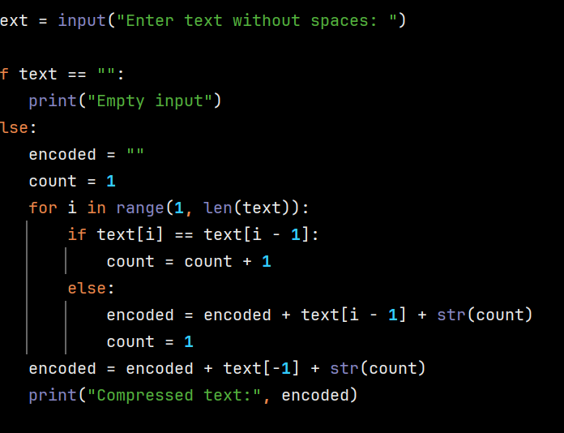

8. Test Cases
Test 1: aaabbc → a3b2c1. Test 2: aaaa → a4.

Sample Output
Input: aaabbc
Output: Compressed text: a3b2c1

9. Conclusion
The program introduces simple string processing and consecutive character counting.

